Country of Origin | Product of Australia
Product Description | *YG* Tenderloin Side Strap off
HAM Number | 2160
Bone-In Beef/ Boneless Beef | Boneless Beef
Points of Specification | - The Tenderloin is prepared from the hindquarter and is removed in one piece from the ventral surface of the lumbar vertebrae and the lateral surface of the ilium. The side strap muscle (M psoas minor) is removed.  - Fat cover removed.  - side strap muscle (M. psoas minor) is removed.
Allergen Statement | No Allergens present
Identity Preserved Product | Hormone Growth Promotant (HGP) Free
Weight Range | 1.4kg – 1.8kg
Packaging Type | IW/VAC
Primary Packaging Specifications | A600 barrier bag 200x810 with Soaker Pad 2 x 1 (141 x 64)
Secondary Packaging Specifications | 9 pieces per Carton: Code 150 brown base with Huntland Classic lid and white strapping
Refrigeration Statement | Keep Chilled
Shelf Life | 100 Days
Ingredients | 100% Australian Beef
Internal label | Not required
External label | HGP FREE, Halal Certified Logo and AI 2497
Organoleptic Specifications | Colour – Bright to dark red with Specs of Fat, no Brown Colour  Odour – No Off Odour  Texture – Not Slimy/ No Bone or Gristle Present
Regulatory Status | This Product has been produced in accordance with Requirements of the Approved Arrangement, FSANZ Code and Aus Meat Requirements.
Company Contact Details | Address: 26 Amberley Crescent Dandenong South, Vic, 3175 Phone: 8780 6320
Created By – Quality Assurance Manager: 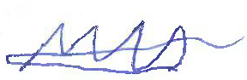 Date: 01/09/2024
Approved By – GM Commercial: 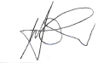 Date: 01/09/2024
Issued By – GM Operations: 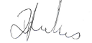 Date: 01/09/2024

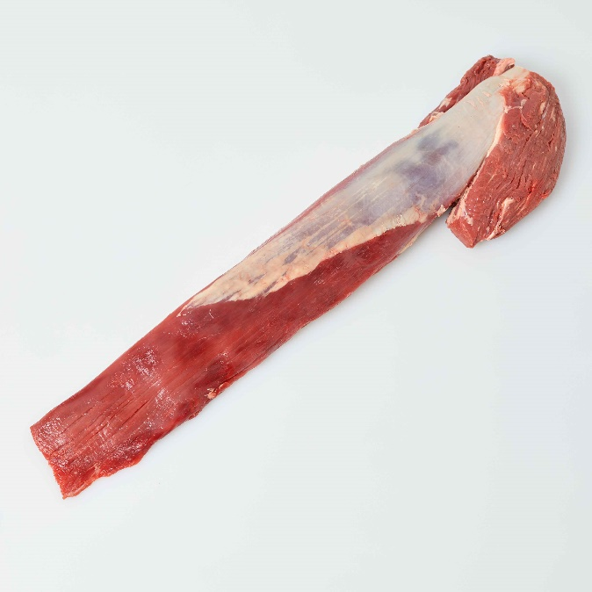 | 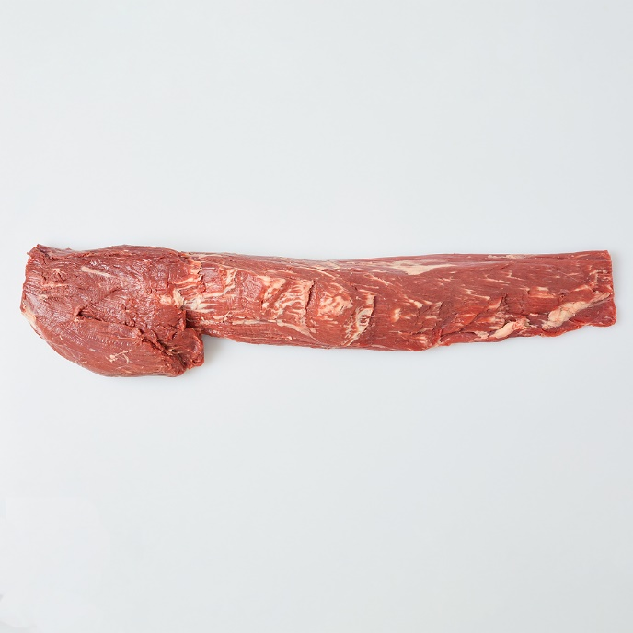
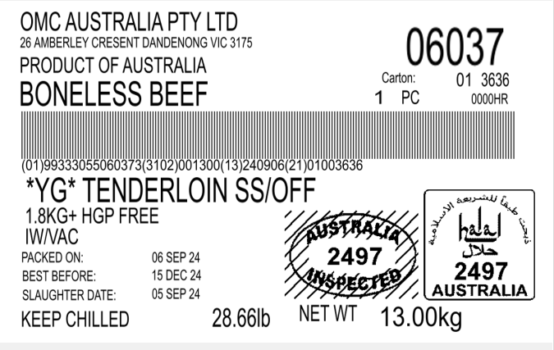 |  | 