Country of Origin | Product of Australia
Product Description | *YG* Striploin
HAM Number | 2140
Bone-In Beef/ Boneless Beef | Boneless Beef
Points of Specification | - The Striploin is prepared from a hindquarter by a cut at the lumbosacral junction to the ventral portion of the flank. The flank is removed 25mm from the eye muscle (M longissimus dorsi) at the cranial end and 0mm at the caudal end.  - 1 Rib.  - Intercostals removed. Supraspinous ligament removed. M multifidi dorsi muscle removed. Ligamentum nuchae removed.  - Both cranial and caudal ends must be squared.  - Less than 10mm fat depth.
Allergen Statement | No Allergens present
Identity Preserved Product | Hormone Growth Promotant (HGP) Free
Weight Range | Over 4.0kg
Packaging Type | IW/VAC
Primary Packaging Specifications | A600 barrier bag 300x810 with Soaker Pad 3 x 2 (141 x 192)
Secondary Packaging Specifications | 4 pieces per Carton: Code 150 brown base with Huntland Classic lid and white strapping
Refrigeration Statement | Keep Chilled.
Shelf Life | 100 Days
Ingredients | 100% Australian Beef
Internal label | Not required
External label | HGP FREE, Halal Certified Logo and AI 2497
Organoleptic Specifications | Colour – Bright to dark red with Specs of Fat, no Brown Colour  Odour – No Off Odour  Texture – Not Slimy/ No Bone or Gristle Present
Regulatory Status | This Product has been produced in accordance with Requirements of the Approved Arrangement, FSANZ Code and Aus Meat Requirements.
Company Contact Details | Address: 26 Amberley Crescent Dandenong South, Vic, 3175 Phone: 8780 6320
Created By – Quality Assurance Manager: 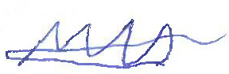 Date: 01/09/2024
Approved By – GM Commercial: 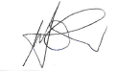 Date: 01/09/2024
Issued By – GM Operations: 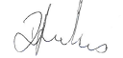 Date: 01/09/2024

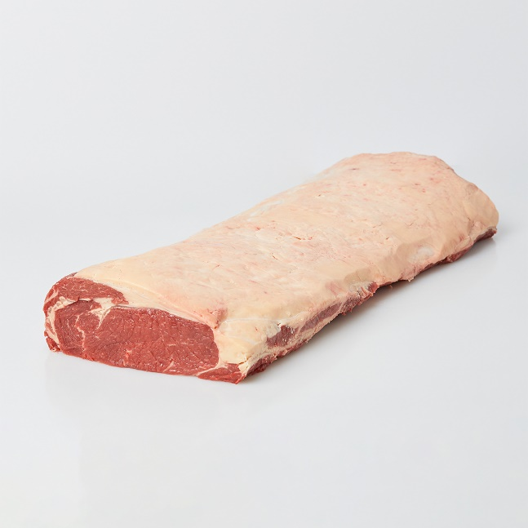 | 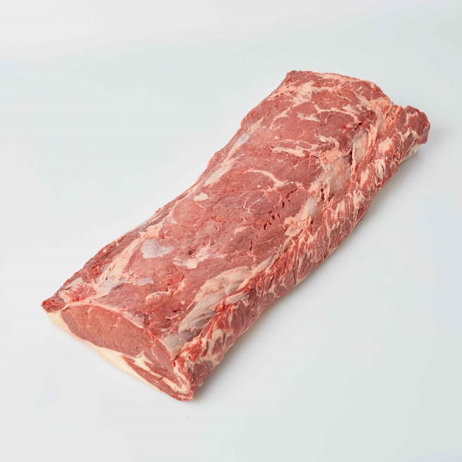
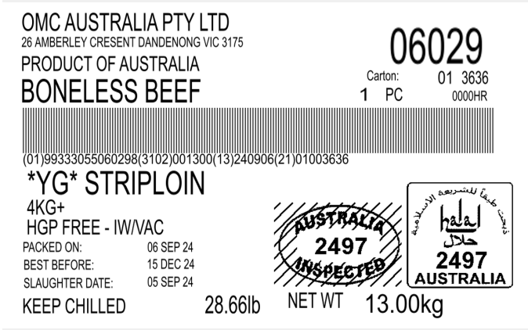 |  | 