Country of Origin | Product of Australia
Product Description | *YG* Rump
HAM Number | 2090
Bone-In Beef/ Boneless Beef | Boneless Beef
Points of Specification | - The Rump is prepared from a Full Rump (item 2080) by the removal of the abdominal muscles from the tail (Flank) leaving the M. tensor faciae latae in situ.  - Heavy connective tissue retained.  - 50mm length of M. Tensor fasciae latae flank (tail) to be retained.  - Less than 10mm fat depth.
Allergen Statement | No Allergens present
Identity Preserved Product | Hormone Growth Promotant (HGP) Free
Weight Range | Under 6.0kg
Packaging Type | IW/VAC
Primary Packaging Specifications | A600 barrier bag 400x650 with Soaker Pad 3 x 2 (141 x 192)
Secondary Packaging Specifications | 4 pieces per carton: Code 150 brown base with Huntland Classic and white strapping
Refrigeration Statement | Keep Chilled.
Shelf Life | 100 Days
Ingredients | 100% Australian Beef
Internal label | Yes
External label | HGP FREE, Halal Certified Logo and AI 2497
Organoleptic Specifications | Colour – Bright to dark red with Specs of Fat, no Brown Colour  Odour – No Off Odour  Texture – Not Slimy/ No Bone or Gristle Present
Regulatory Status | This Product has been produced in accordance with Requirements of the Approved Arrangement, FSANZ Code and Aus Meat Requirements.
Company Contact Details | Address: 26 Amberley Crescent Dandenong South, Vic, 3175 Phone: 8780 6320
Created By – Quality Assurance Manager:  Date: 01/09/2024
Approved By – GM Commercial: 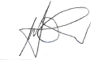 Date: 01/09/2024
Issued By – GM Operations: 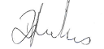 Date: 01/09/2024

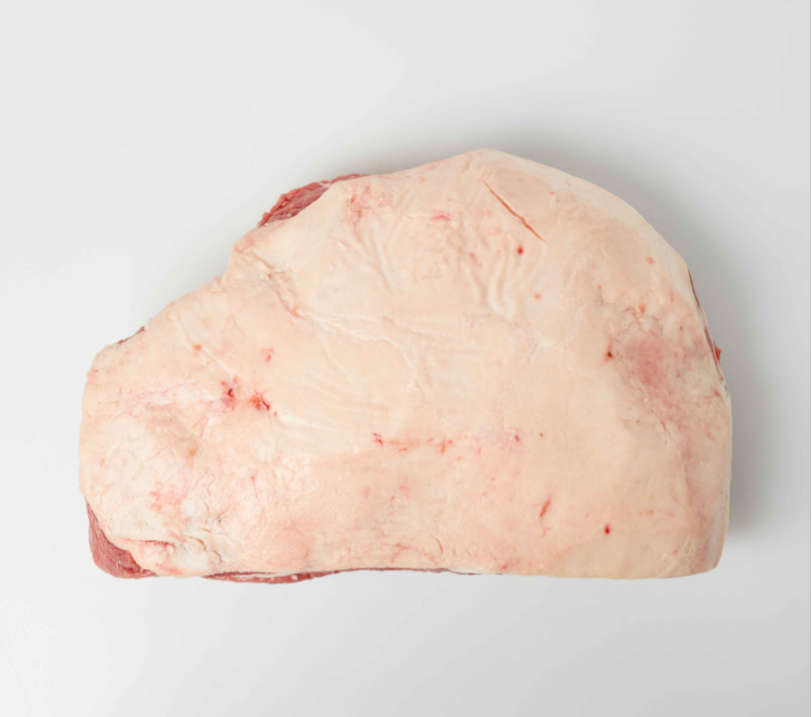 | 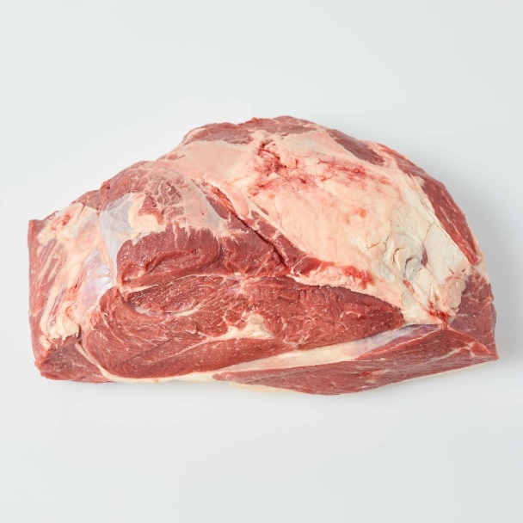
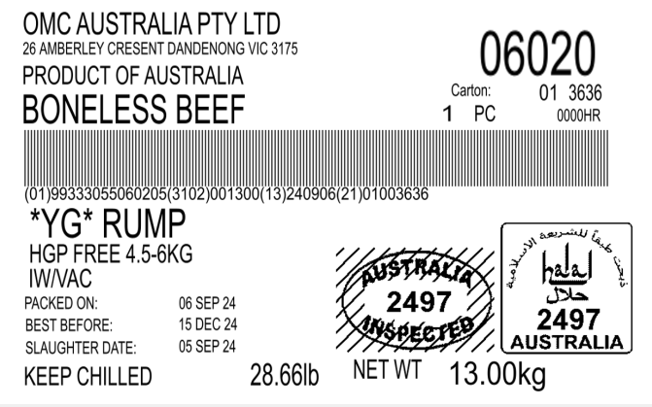 | 