Country of Origin | Product of Australia
Product Description | *YG* Inside
HAM Number | 2010
Bone-In Beef/ Boneless Beef | Boneless Beef
Points of Specification | - Inside is situated caudal/medial to the femur and is attached to the os coxae (aitchbone) and removed by the following natural seam between the thick flank and silverside. The pizzle butt, fibrous tissue and the inguinal lymph node and surrounding fat are removed.  - Less than 10mm fat depth.
Allergen Statement | No Allergens present
Identity Preserved Product | Hormone Growth Promotant (HGP) Free
Weight Range | N/A
Packaging Type | IW/VAC
Primary Packaging Specifications | A600 barrier bag 400x500
Secondary Packaging Specifications | 3 pieces per Carton: Code 150 brown base with Huntland Classic and white strapping
Refrigeration Statement | Keep Chilled.
Shelf Life | 100 Days
Ingredients | 100% Australian Beef
Internal Label | Yes
External label | HGP FREE, Halal Certified Logo and AI 2497
Organoleptic Specifications | Colour – Bright to dark red with Specs of Fat, no Brown Colour  Odour – No Off Odour  Texture – Not Slimy/ No Bone or Gristle Present
Regulatory Status | This Product has been produced in accordance with Requirements of the Approved Arrangement, FSANZ Code and Aus Meat Requirements.
Company Contact Details | Address: 26 Amberley Crescent Dandenong South, Vic, 3175 Phone: 8780 6320
Created By – Quality Assurance Manager:  Date: 01/09/2024

Approved By – GM Commercial: 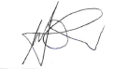 Date: 01/09/2024
Issued By – GM Operations: 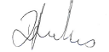 Date: 01/09/2024

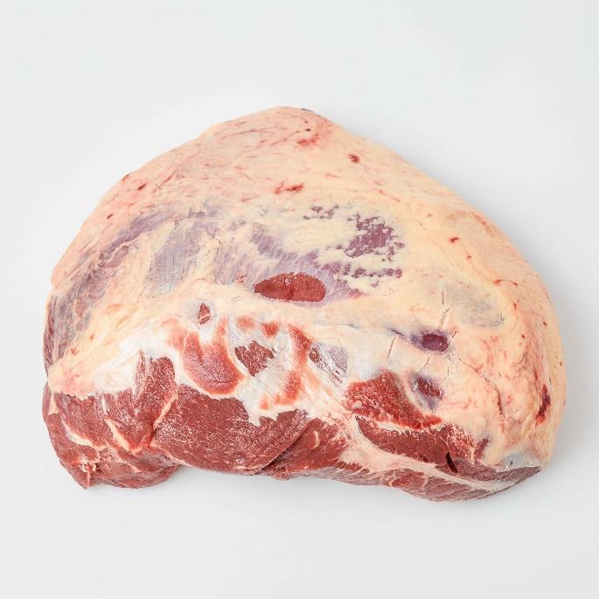 | 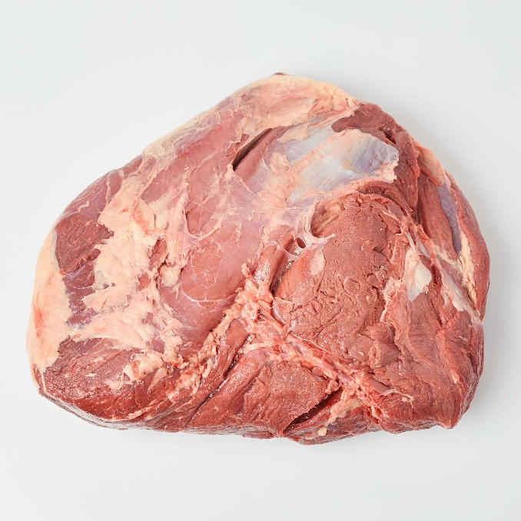
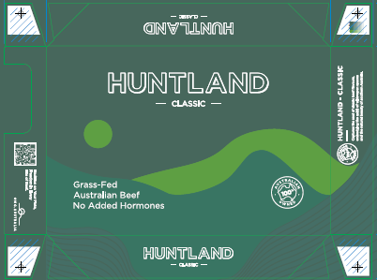
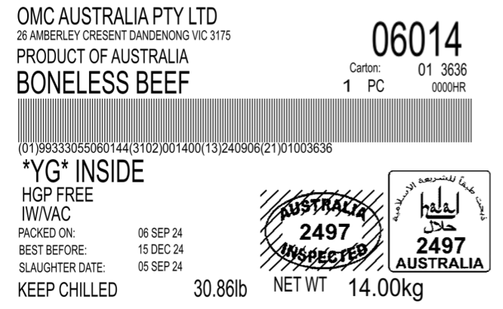 | 