Country of Origin | Product of Australia
Product Description | *YG* Cube Roll
HAM Number | 2240
Bone-In Beef/ Boneless Beef | Boneless Beef
Points of Specification | - The Cube Roll is prepared from a rib set and consists of the muscle underlying the dorsal aspect of the ribs (caudal edge of the 6th rib to the 10th rib inclusive).  - 7 Rib.  - M. ilocostalis removed.
Allergen Statement | No Allergens present
Identity Preserved Product | Hormone Growth Promotant (HGP) Free
Weight Range | Under 3.5kg
Packaging Type | IW/VAC
Primary Packaging Specifications | A600 barrier bag 250x600 with Soaker Pad 2 x 1 (141 x 64)
Secondary Packaging Specifications | 5 pieces per Carton: Code 151 brown base with Huntland Classic lid and white strapping
Refrigeration Statement | Keep Chilled.
Shelf Life | 100 Days
Ingredients | 100% Australian Beef
Internal label | Not required
External label | HGP FREE, Halal Certified Logo and AI 2497
Organoleptic Specifications | Colour – Bright to dark red with Specs of Fat, no Brown Colour  Odour – No Off Odour  Texture – Not Slimy/ No Bone or Gristle Present
Regulatory Status | This Product has been produced in accordance with Requirements of the Approved Arrangement, FSANZ Code and Aus Meat Requirements.
Company Contact Details | Address: 26 Amberley Crescent Dandenong South, Vic, 3175 Phone: 8780 6320
Created By – Quality Assurance Manager:  Date: 01/09/2024
Approved By – GM Commercial: 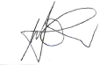 Date: 01/09/2024
Issued By – GM Operations: 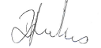 Date: 01/09/2024

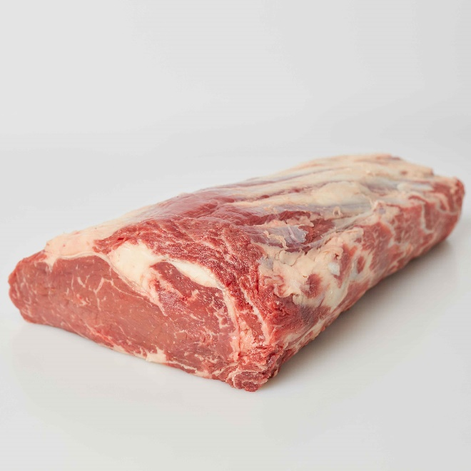 | 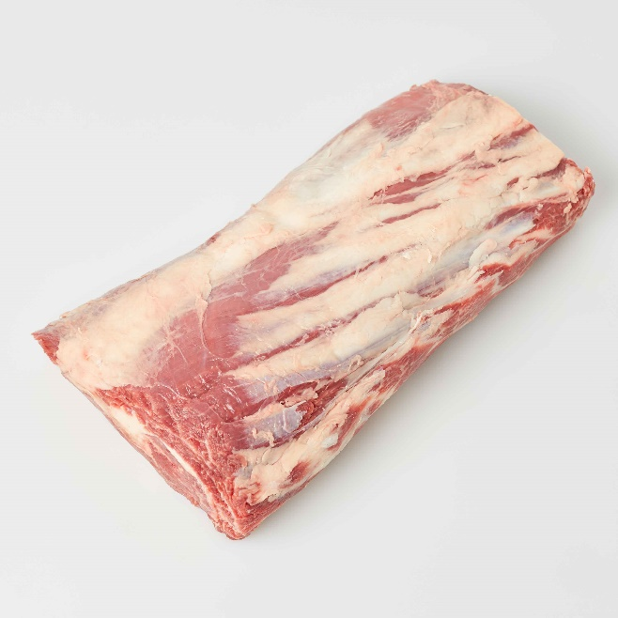
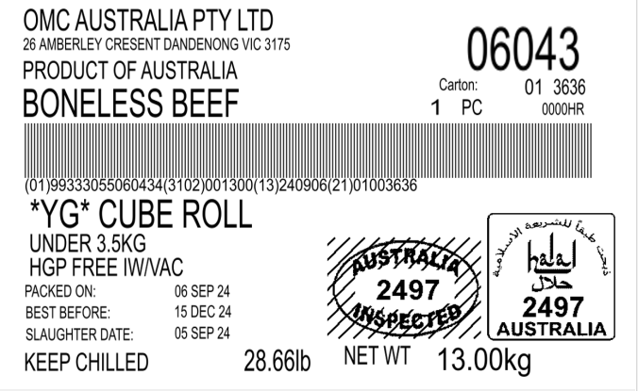 | 